The Mindful Gifts CIC Story
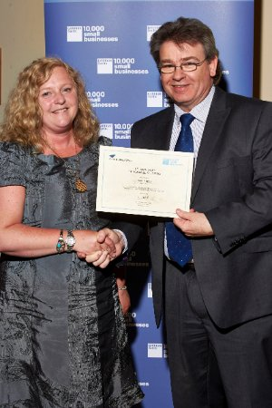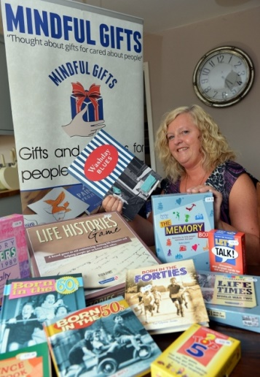
Mindful Gifts CIC was set up by myself, Vicki Phipps, in 2013 when I found that there was a lack of suitable activities for people with dementia and that families didn’t always know what to buy a loved one with dementia when it came to special occasions such as Birthdays and Christmas. I had just been made redundant having worked in health and social care and just completed business management programme. So with my knowledge and experience behind me I put all my energy into a passion that I had for making a difference to the lives of people with dementia and their carers.
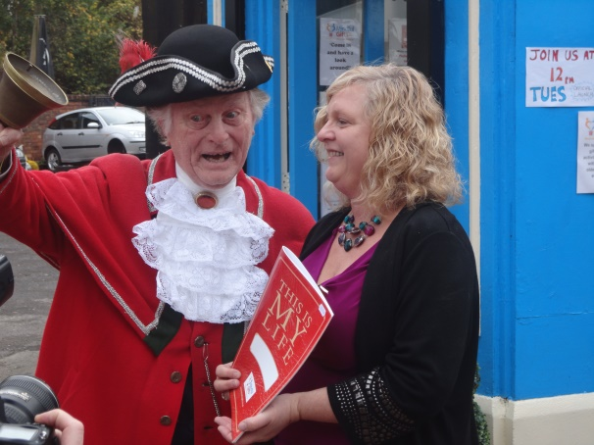
After working from home and in the community I found I needed a base for Mindful Gifts and the increasing amount of activities and gifts that was now on offer through our website www.mindfulgifts.co.uk. The small shop on the corner of King Street was perfect as not only the rent was low but Darlaston was where I had spent a lot of time as a child and I had fond memories of this once thriving town!
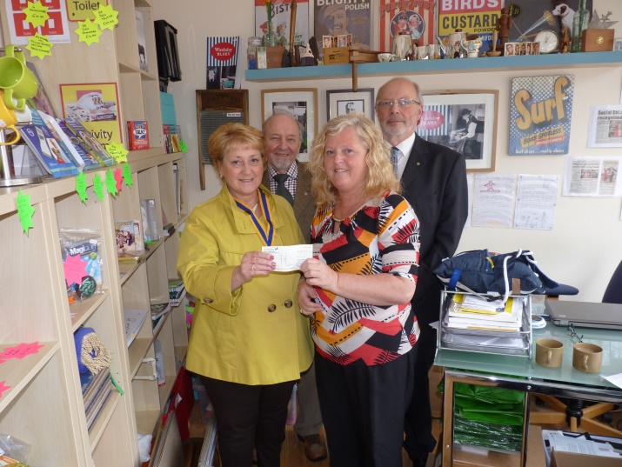
During the year in the tiny shop (without a toilet!) , I would look across the street and wish that Darlaston Carpets was available as this shop was much bigger, was a beautiful building and would be perfect to create a ‘unique shopping experience’ for all customers who visited the shop. My dream came true and in October 2015, I had the keys to a very large but empty shop!
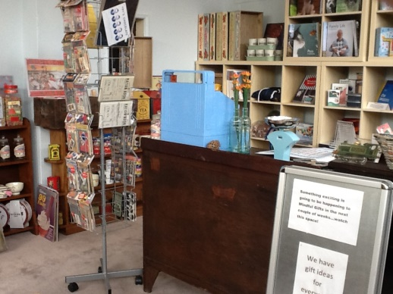

This is what the shop would have looked like if I hadn’t found the shop fittings below!

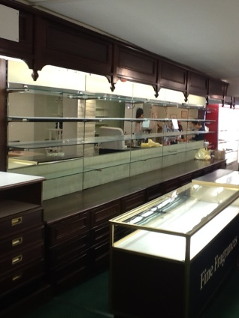

The exciting bit was planning how the shop was going to look but furthermore how it was going to bring back memories for not just people with dementia buy for everyone! Once I had a good idea of what it was going to look like, I then went about finding shop fittings, stock, furniture, memorabilia and everything else that makes the shop do its job in ‘rolling back memories’.
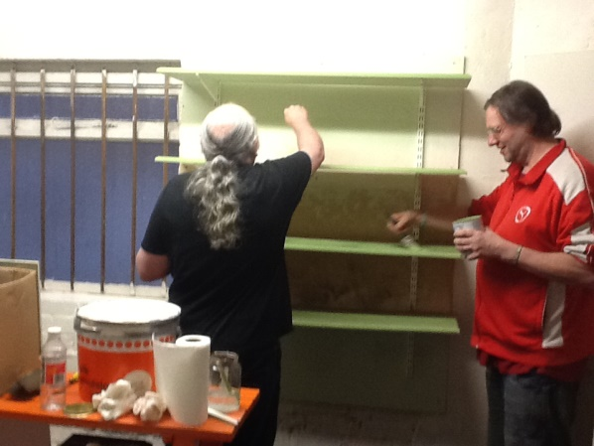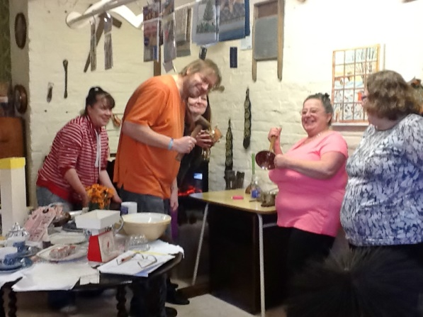
In November 2015, the shop opened, with the help of volunteers and family who gave their time to create something special.
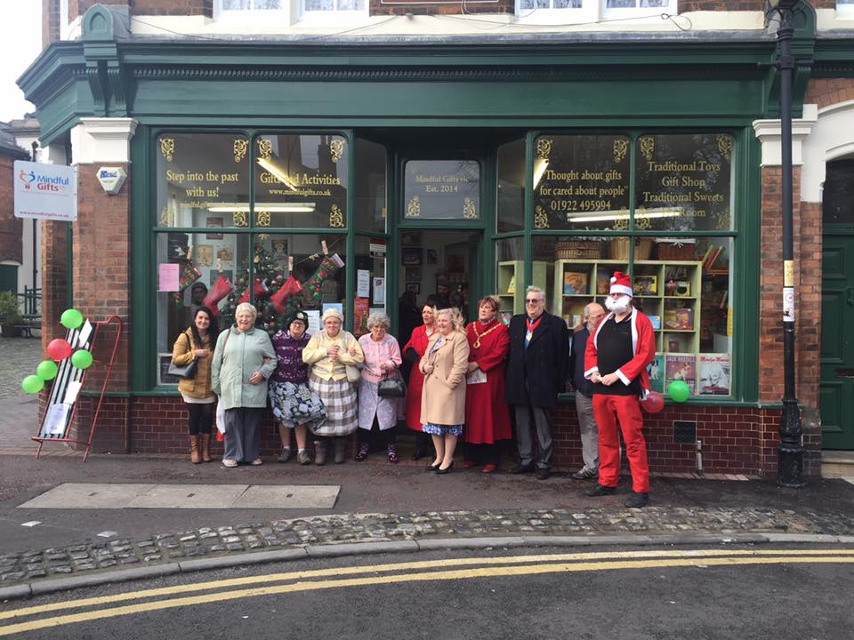
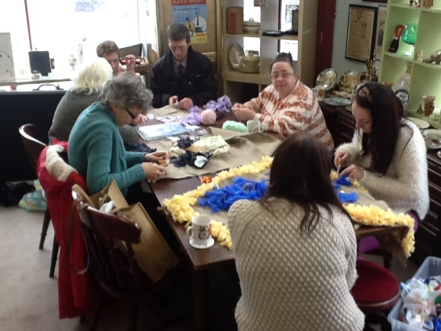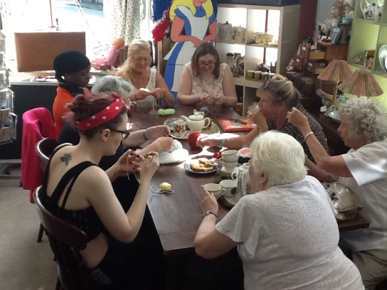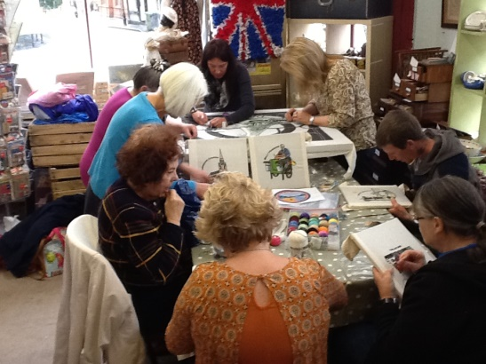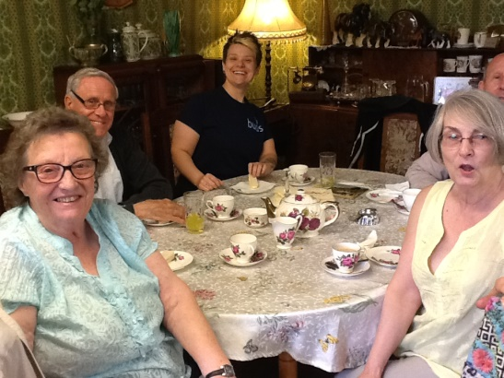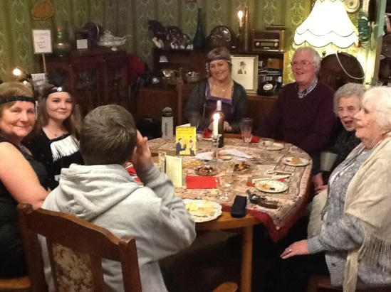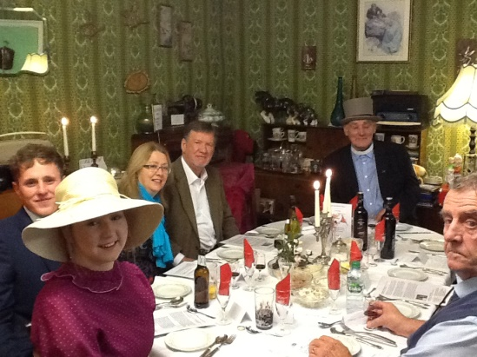
The shop has continued to grow and offers a range of activities and events. This has included:
- Crocheting
- Rag Rug making
- Sewing
- Vintage tea Parties & Birthday Parties
- Quiz Nights
- Themed Decades Events (1910s - 1980s)
These activities have befitted many people and friends have been found, enabling the community to come together, back in the ‘High ‘street.
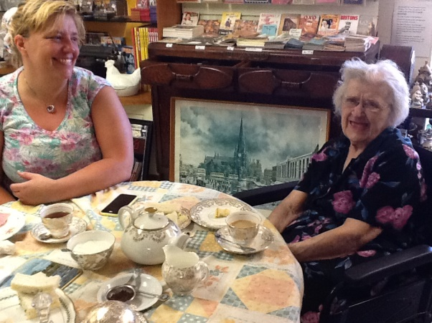
Mindful Gifts CIC has also provided an environment for people with memory problems to tap into their past memories. The living room and scullery has been ideal to have a cuppa out of china cups and reminisce over their surroundings. The rest of the shop has enabled people to rekindle their childhood by looking at the toys, smell the carbolic soap and transport them back to days of doing the washing or being scrubbed in the tin bath with it!, and taste the traditional sweets they once enjoyed.
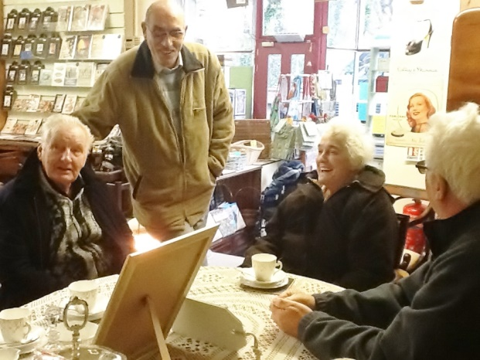

We have enjoyed seeing; residents from care homes, dementia groups and cafes, older people groups and family and friends bringing in their loved ones.
As well as benefiting people with dementia, we also are there for the family who are providing care to their loved ones. We provide sign posting to essential services and provide ‘respite’ from their caring duties. We also provide a listening ear which can make a massive difference when the carer can feel so isolated.
Mindful Gifts CIC runs as a community interest company. This means we operate on behalf of the community and not for personal gain. What makes us different to a charity is that we are not reliable on funding and are self-sustainable by selling products and services. However, we believe in offering ‘good value for money’ so we make things as affordable as possible.
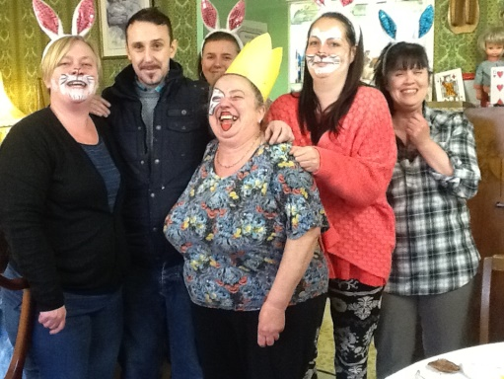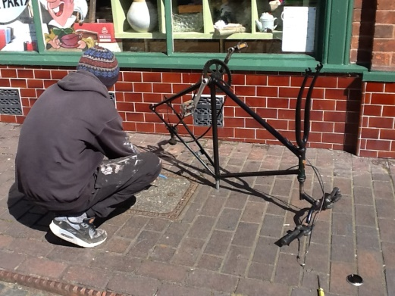

To be able to operate Mindful Gifts CIC, we are mainly run by volunteers. Without the support of our volunteers we wouldn’t be able to deliver our activities and events, make your tea and coffee or prepare your tea parties. The shop would be full of dust and I would look very stressed! So a big thank you to all our committed volunteers who work very hard in between drinking tea and coffee of course!
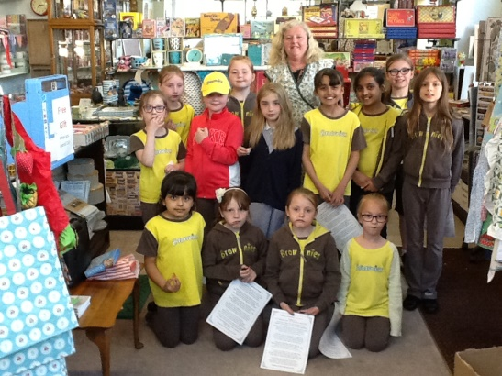
So, all in all, Mindful Gifts CIC is for the community, providing a lot of ‘good’ for everyone. How you can help us carry on doing the good is by spreading the word, donating unwanted items, joining in with the activities or events, by volunteering, making cakes, buying your gifts from us, purchasing your activities for your care home/hospital/organisation from us or by just coming in the shop and saying hello!

In our first year we have:
- Held 60 tea parties for care homes, groups and families
- Supported 36 volunteers including long term unemployed people to get back into work
- Supported an extra 30 young people
- Delivered 150 activity sessions
- Hosted the ‘Silver thread Tapestry Project’ Darlaston Tapestry Workshop
- Held day events including Mad Hatters Tea Party, Santa’s Tea Party
- Facilitated Santa’s Grotto for Darlaston Town Centre
- Delivered talks to the community
- Held Dementia Awareness Sessions
- Become a ‘ Safe Place’ for vulnerable people
- Held evening events including Titanic Night, 20s Night, 40s Night, Quiz Night
- Provided a base for the Creative Aims Group
- Held a Care Homes Open day
- Provided training sessions
- Provided an area where people can ‘drop in’ and get a warm welcome, a listening ear and a cup of tea!

Best Wishes,

Vicki Phipps
Founder of Mindful Gifts CIC
www.mindfulgifts.co.uk
mindful.gifts@yahoo.com
Mindful Gifts CIC, 1 Church Street, Darlaston, Walsall, WS10 8DS
01922 495994

